**1. Environment Dependency**

Programming Environment:

- Java SE 17 Development Kit

- Eclipse Integrated Development Environment (IDE) Version: 2023-06 (4.28.0)

Runtime Environment:

-Java SE 17 Runtime Environment (JRE)

- Apache Tomcat 10.1 server

**2. Import the project**

- Import the project code using Eclipse

- Ensure that the project build path and deployment path are properly configured

**3. Configure the Tomcat server**

- Configure the Tomcat server in Eclipse

- Ensure that the Tomcat server can run correctly

**4. modify the database configuration**

- Find the database configuration file (DBConnect.java) in the project and modify the database connection parameters to suit the local database environment.

**5. Run the project**

- Deploy the project to the Tomcat server

- Start the Tomcat server and access the project's URL address.

**6. Database**

- The backend data required for the code to run is provided by the database MySQL, which has been set up.

userinfo table:

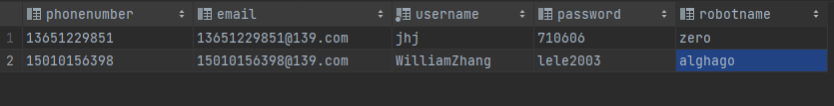

history table:

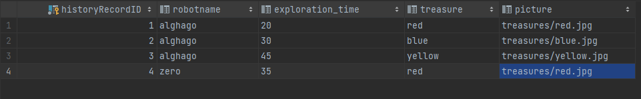

exploration table(A table intended to record real-time data):

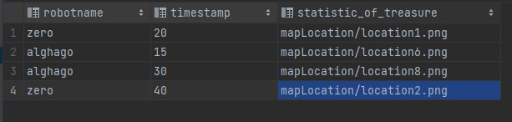

**7. Function**

**(A) Login Function**

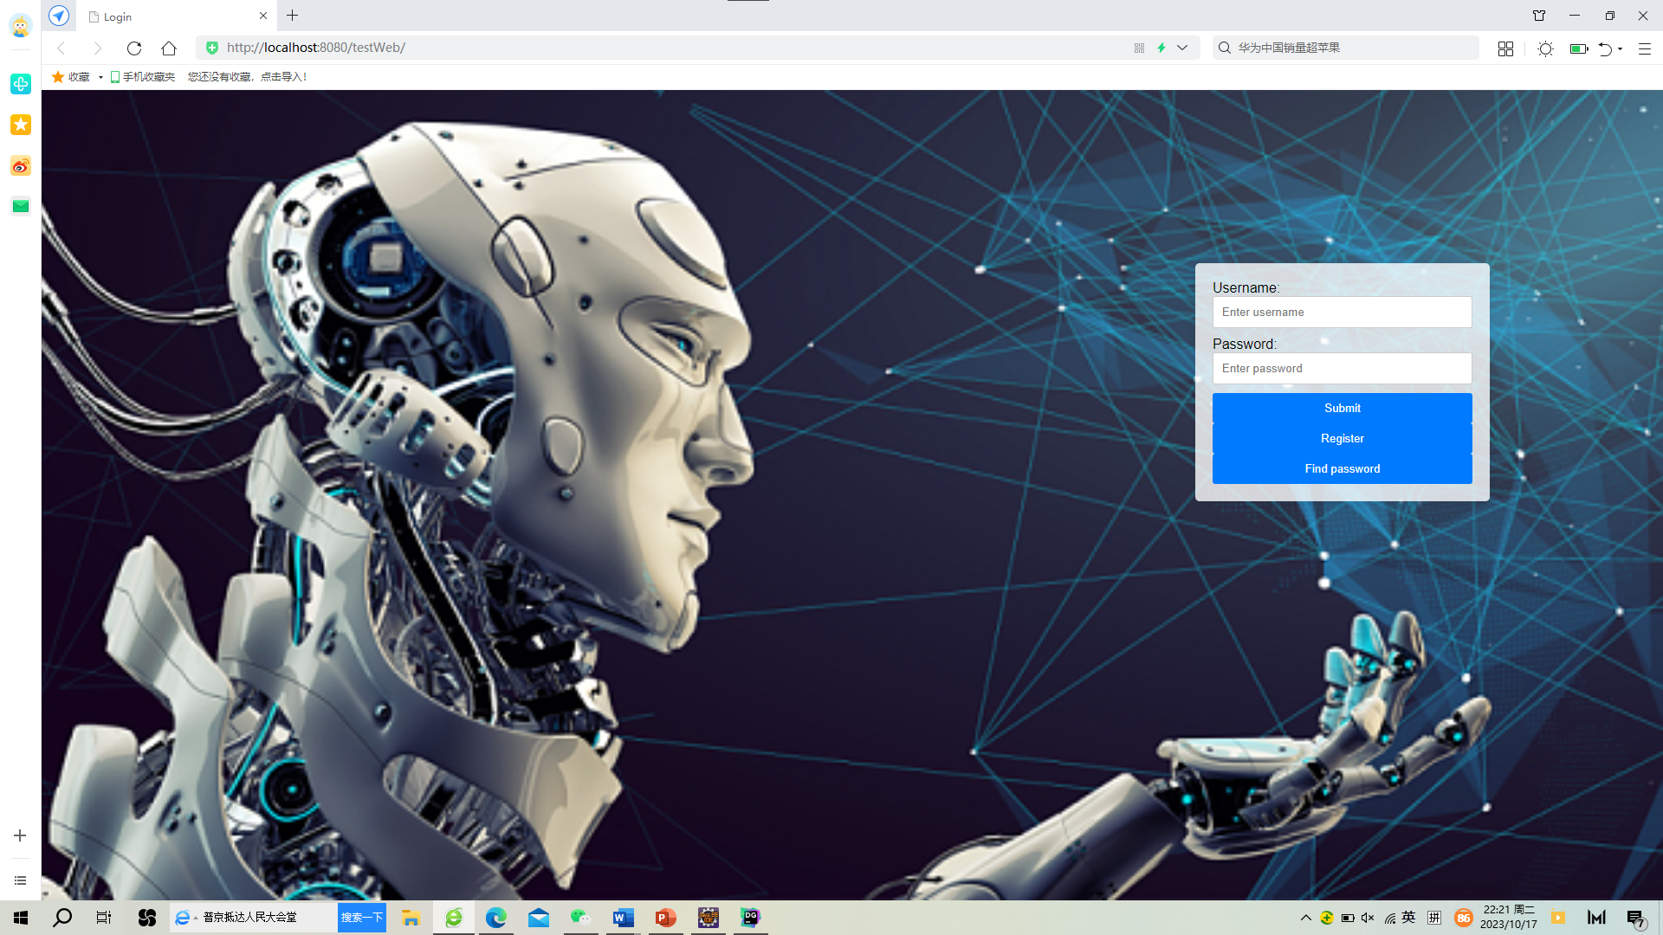

When you intend to login, you need to input the correct information in the username and password fields and click the register button.

1. **When you input the wrong username or password**

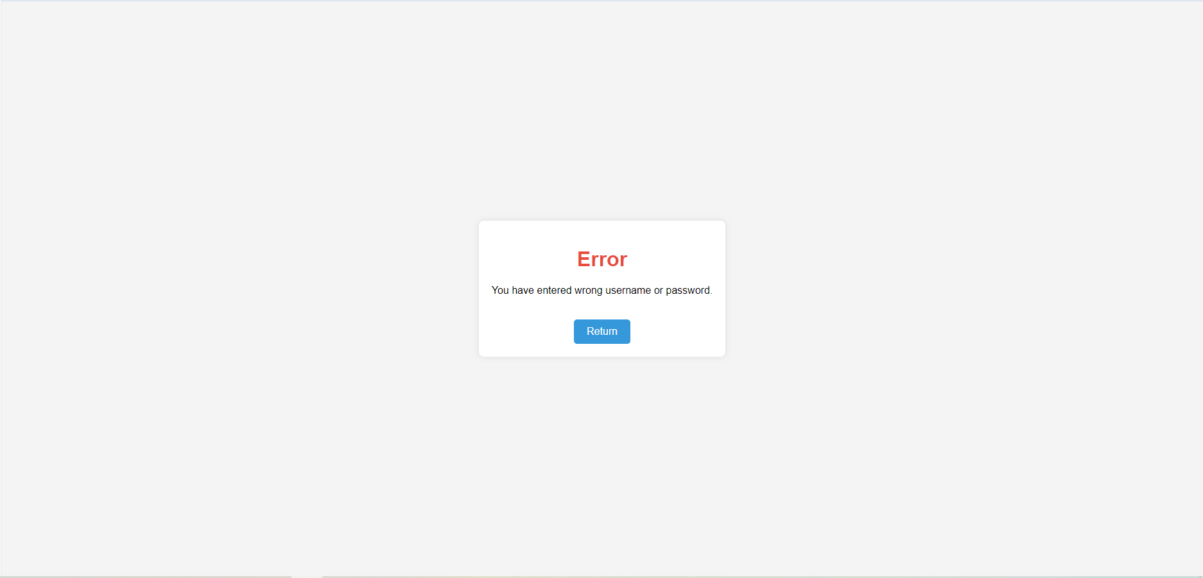

Now you can click the “return” button go back to login page.

1. **When you input the correct username and password**

Login page will automatically redirect to the welcome page

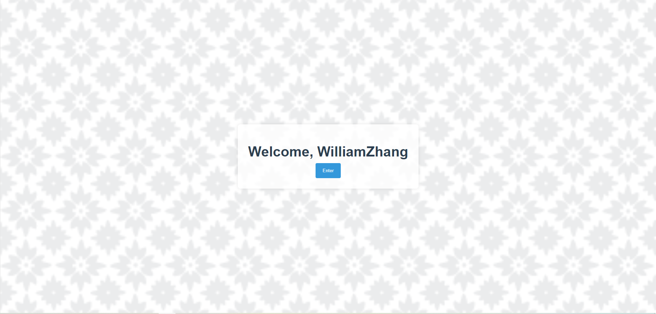

It will display “Welcome, username”.

Now you can click the “Enter” button move on to module page.



**(B) Register Function**

If you don’t have an account, you need to register one.

Click the “Register” button, it will redirect to register page.

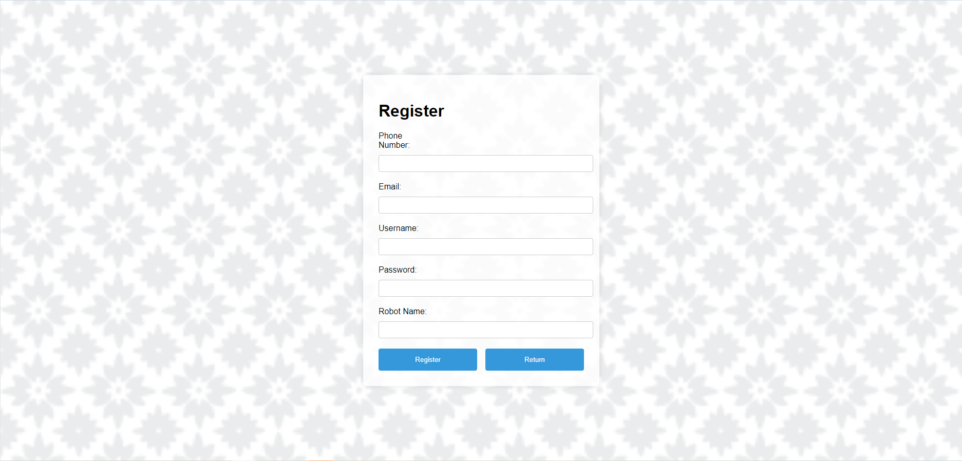

In register page, you need to input you need to input your PhoneNumber, Email, Username, Password and RobotName.

Each attribute’s value must not duplicate any existing corresponding information in the database. Otherwise, a corresponding prompt will pop up on the page.

For example: If you input duplicate PhoneNumber

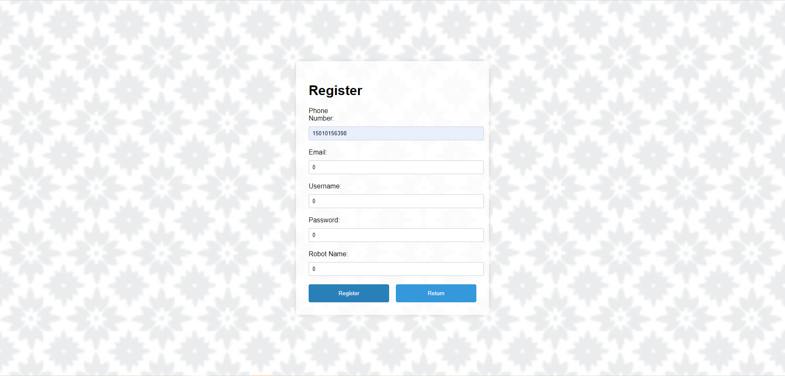

There will be

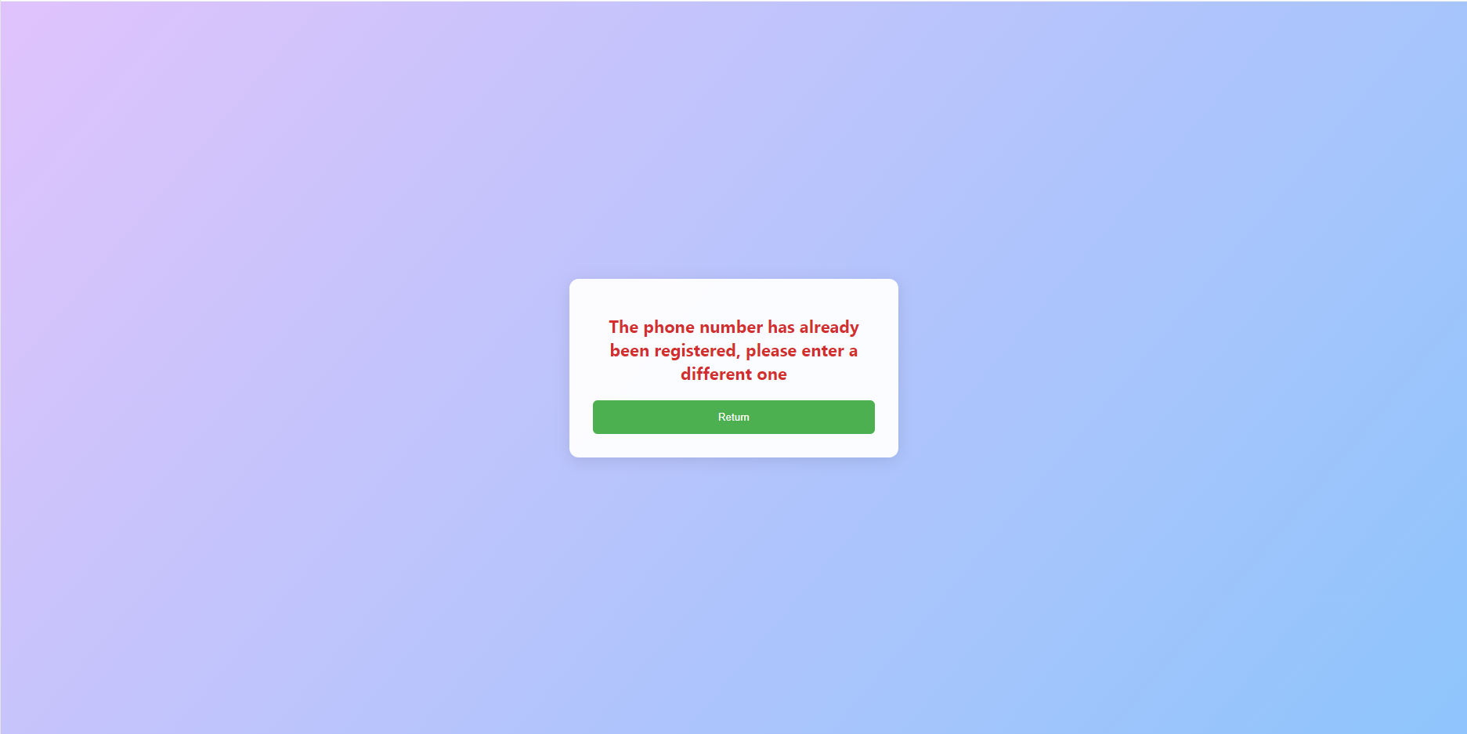

Now you can click “Return” go back to register page

The same scenario for Email, Username, Password and RobotName

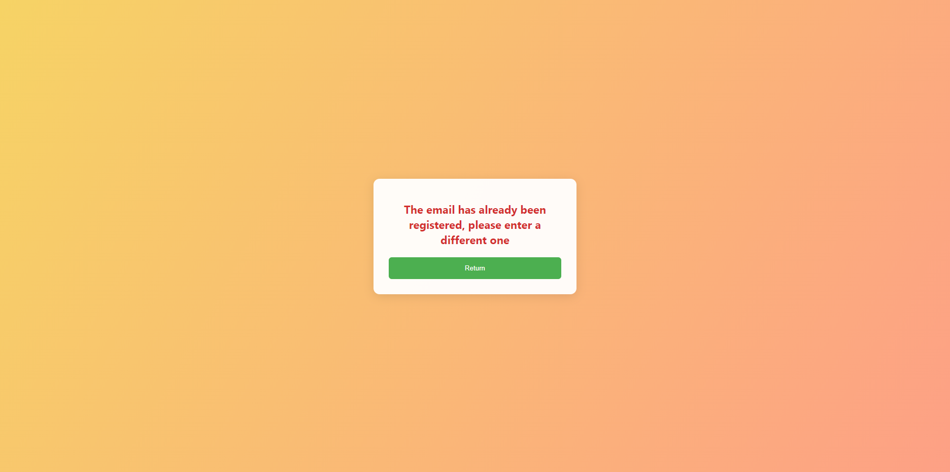

If you input the correct attributes

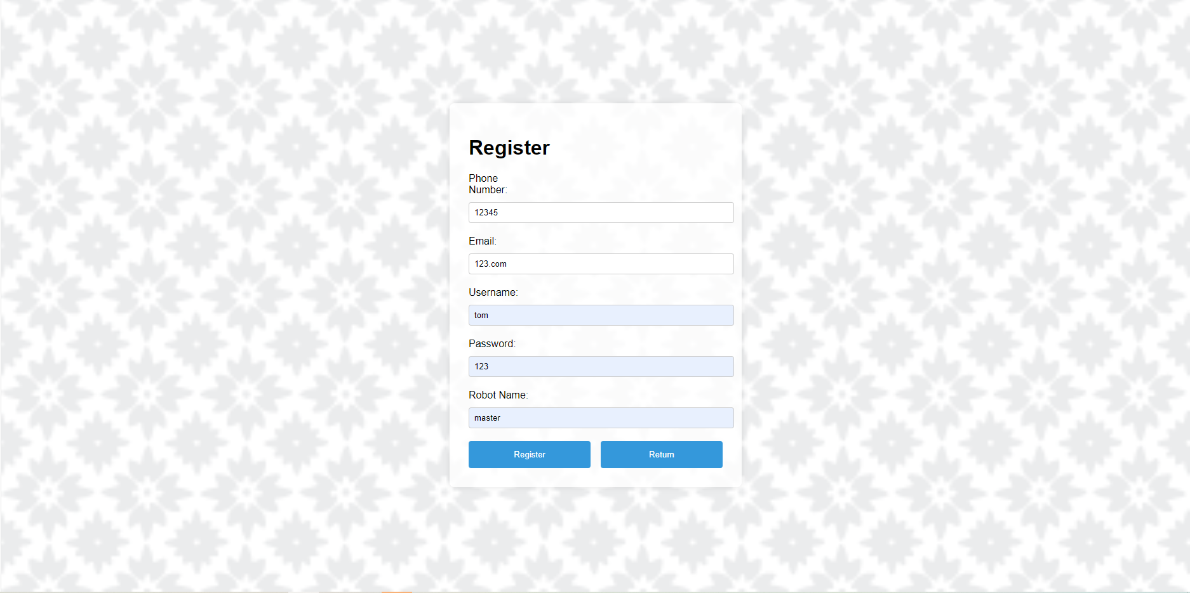

After clicking the “Register” button, it will redirect to login page.

The updated database is shown in the following diagram.

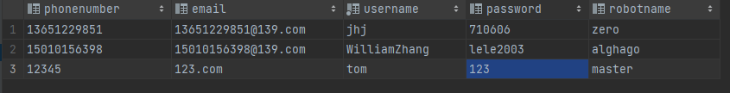

**(C) Find Password Function**

If you forget your password, you can click the “Find_Password” button.

You should input your correct username and new password

1. **If you input wrong username**

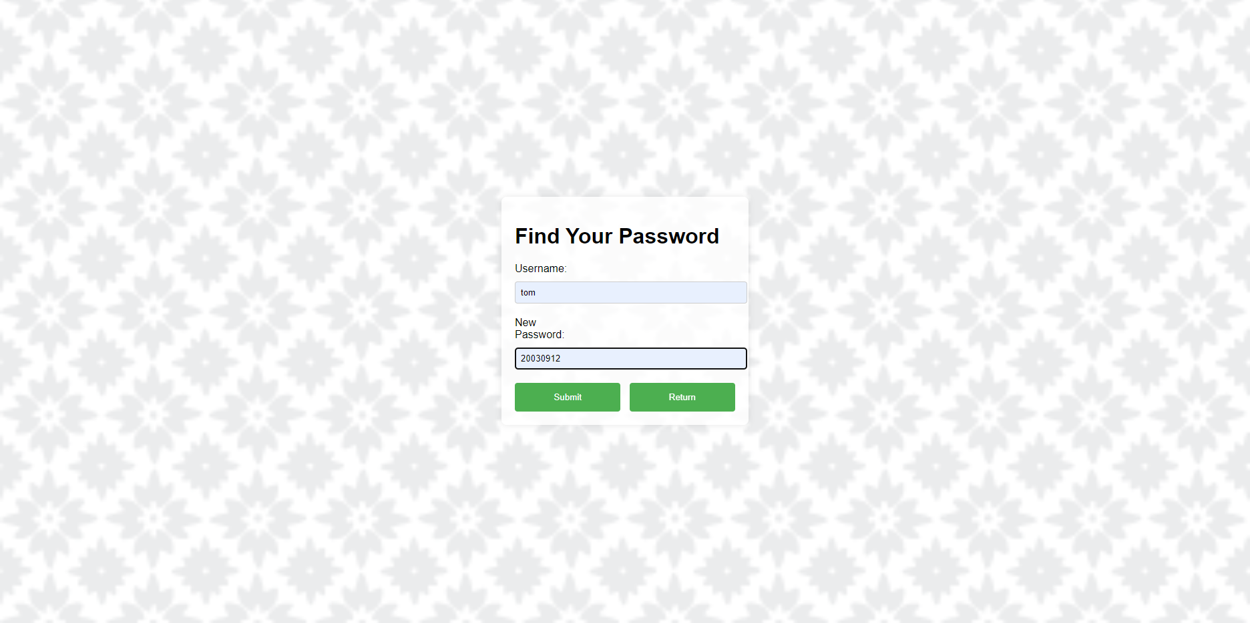

After clicking the “submit button”, there will be

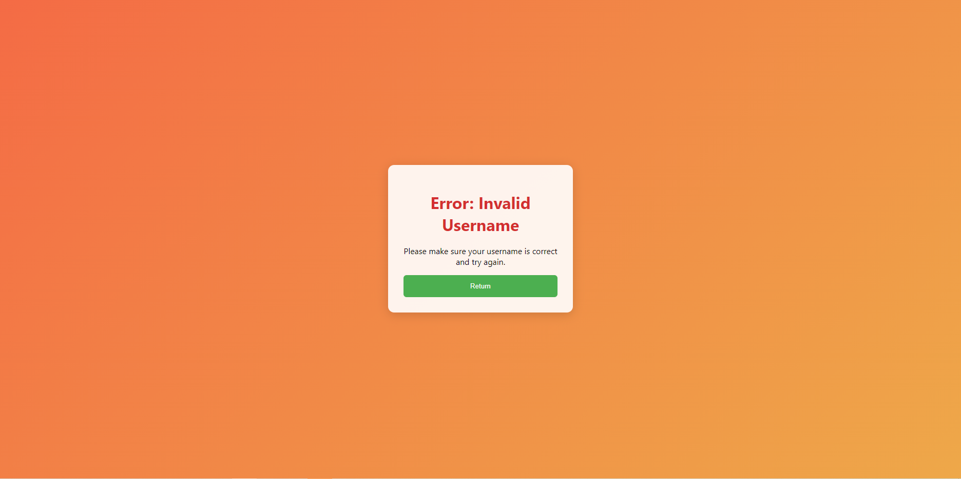

Now you can click the “Return” button go back to Find Password page.

1. **If you input the correct username, there will be**

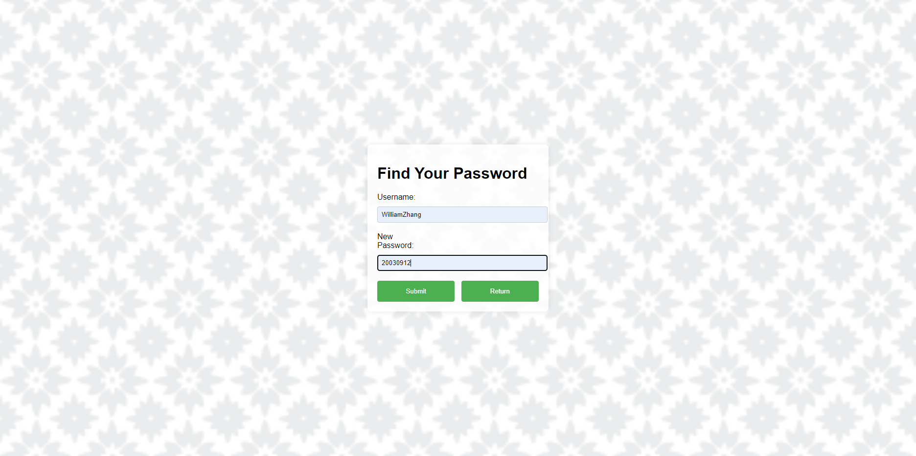

After clicking the “Submit” button

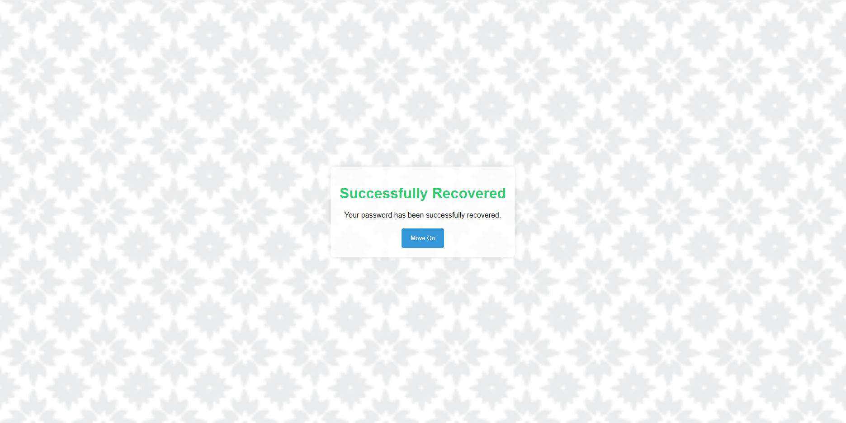

Now, you can click the “Move_on” button to login page.

The updated database is shown in the following diagram.

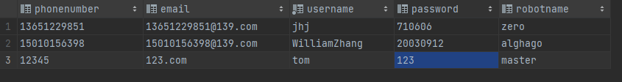

**(D) Search real-time data function**



After clicking the “Search” button, the webpage will display real-time data corresponding to the user’s associated robot.

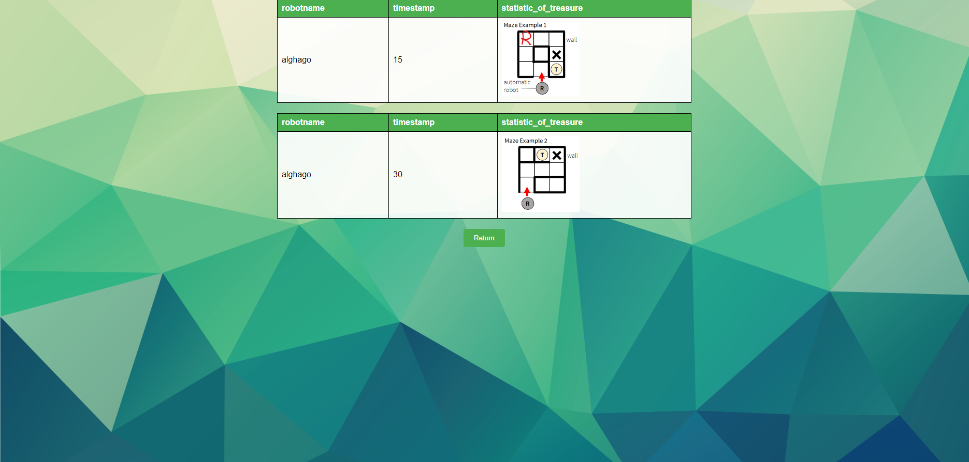

Now you can click the “Return” button go back to module page.

**(E) History Function**

After clicking the “History” button, the webpage will display the historical information of the robot corresponding to the user.

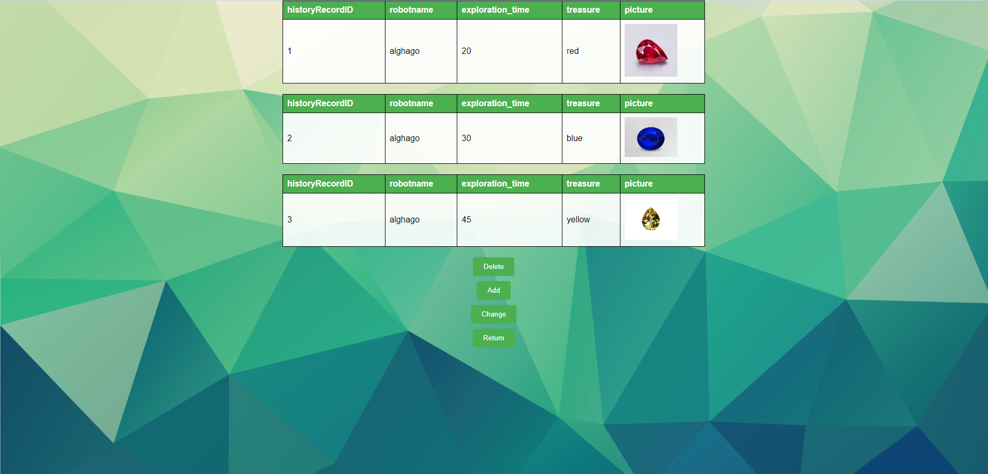

There are three functions in history page

1. **Delete Function**

After clicking the “Delete” button, the page will automatically redirect to delete page.

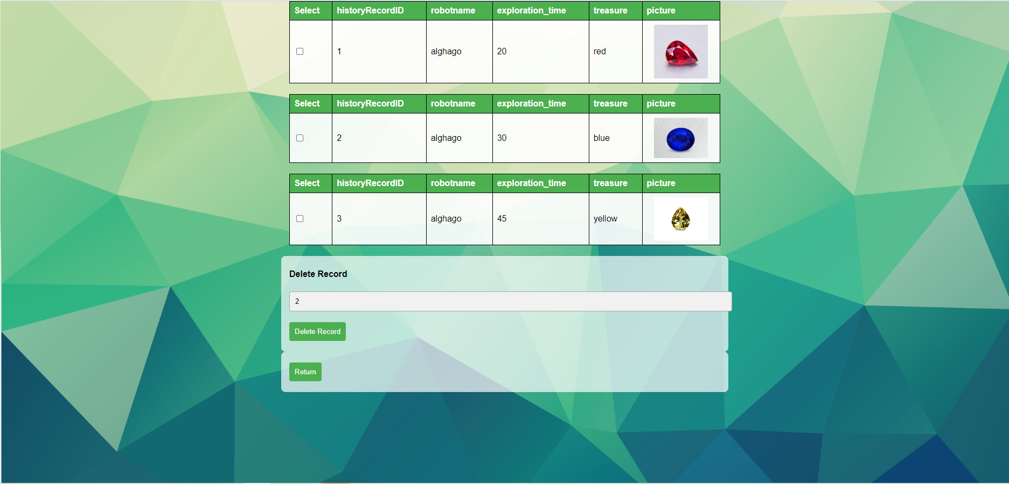

Now you can input the historyRecordID of the history you want to delete and then click the “Delete Record” button

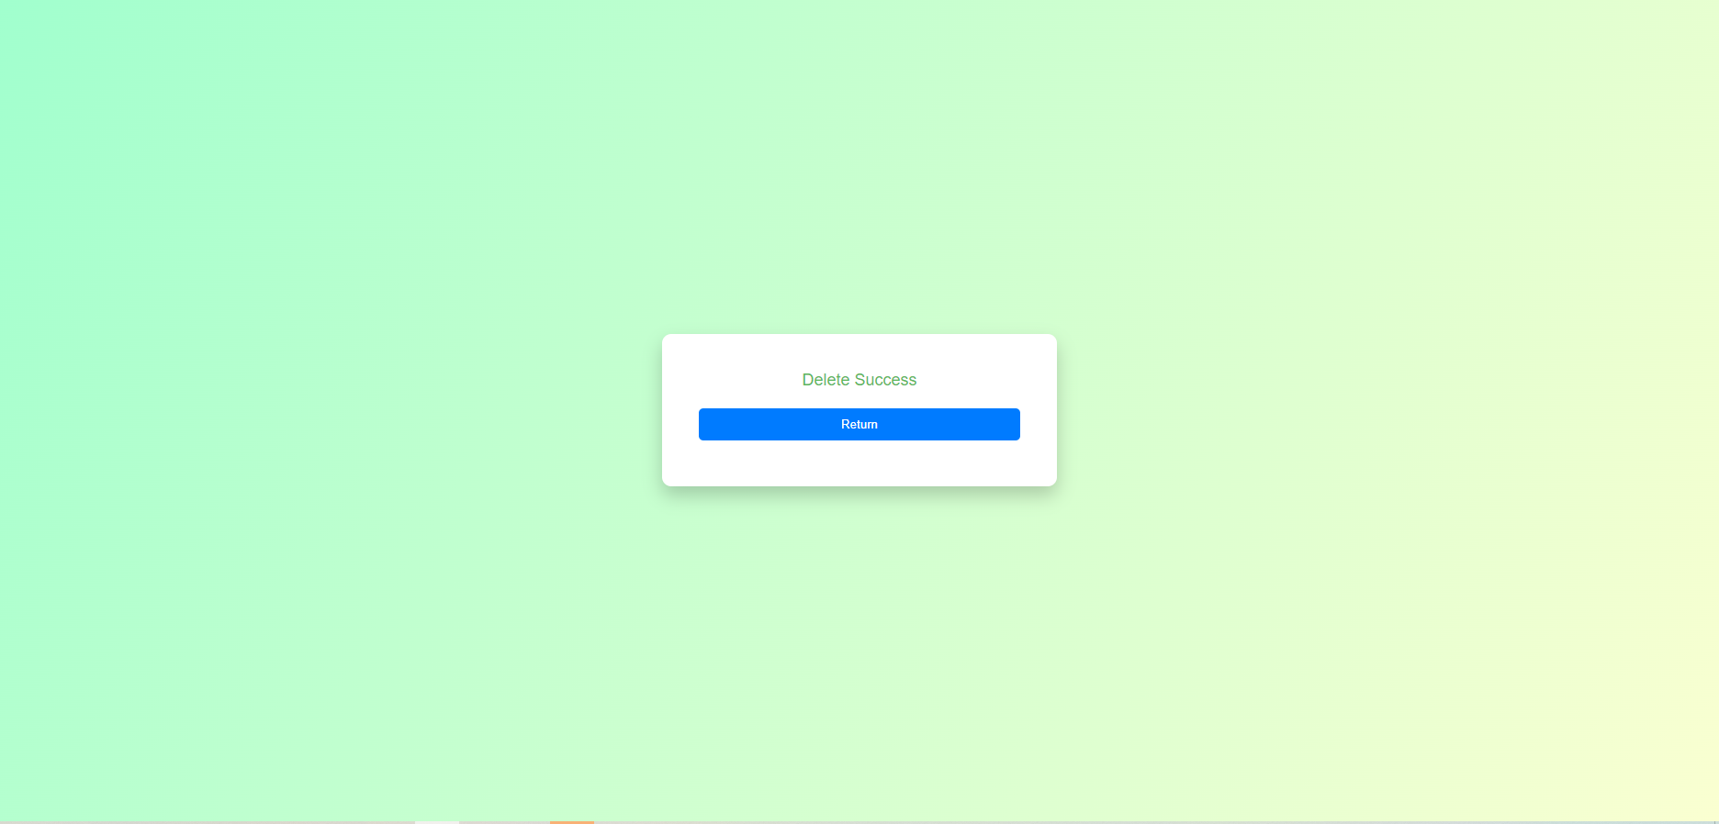

Now you can click the “Return” button go back to history page.

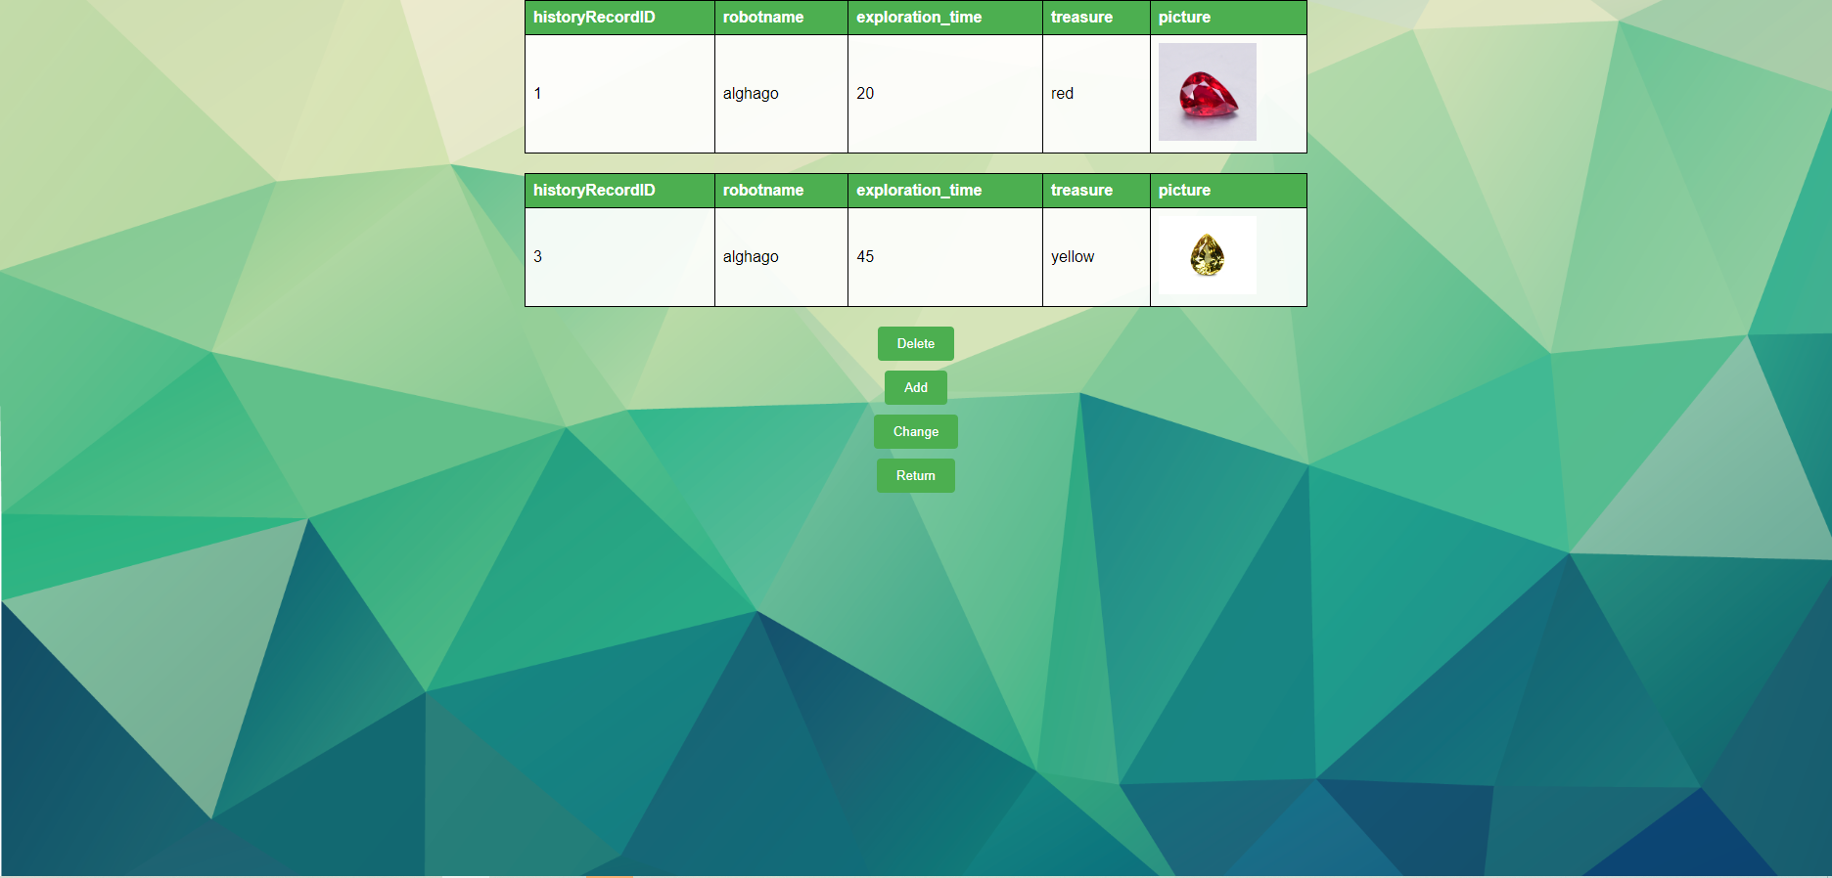

You can find that the correspond history disappear from history page.

The updated database is shown in the following diagram.

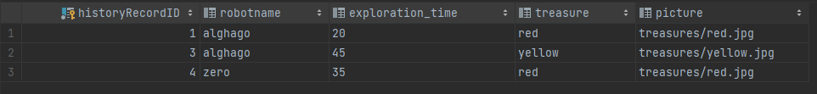

1. **Add function**

After clicking the “Add” button, the page will automatically redirect to add page.

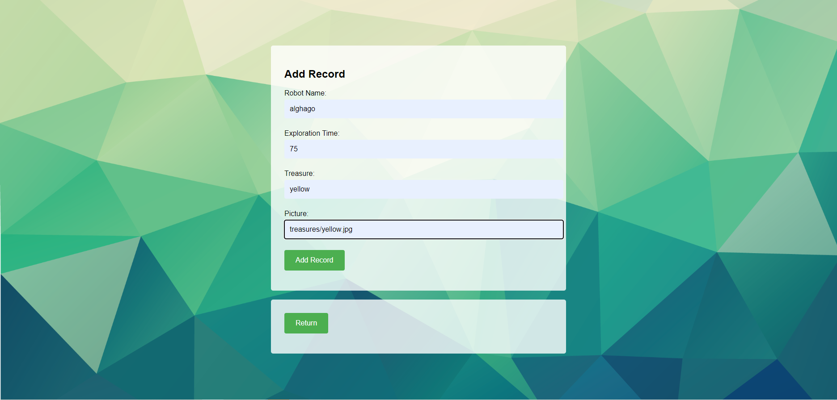

You should input your RobotName, Exploration time, Treasure and Picture at the designated place, then click the “Add Record” button.

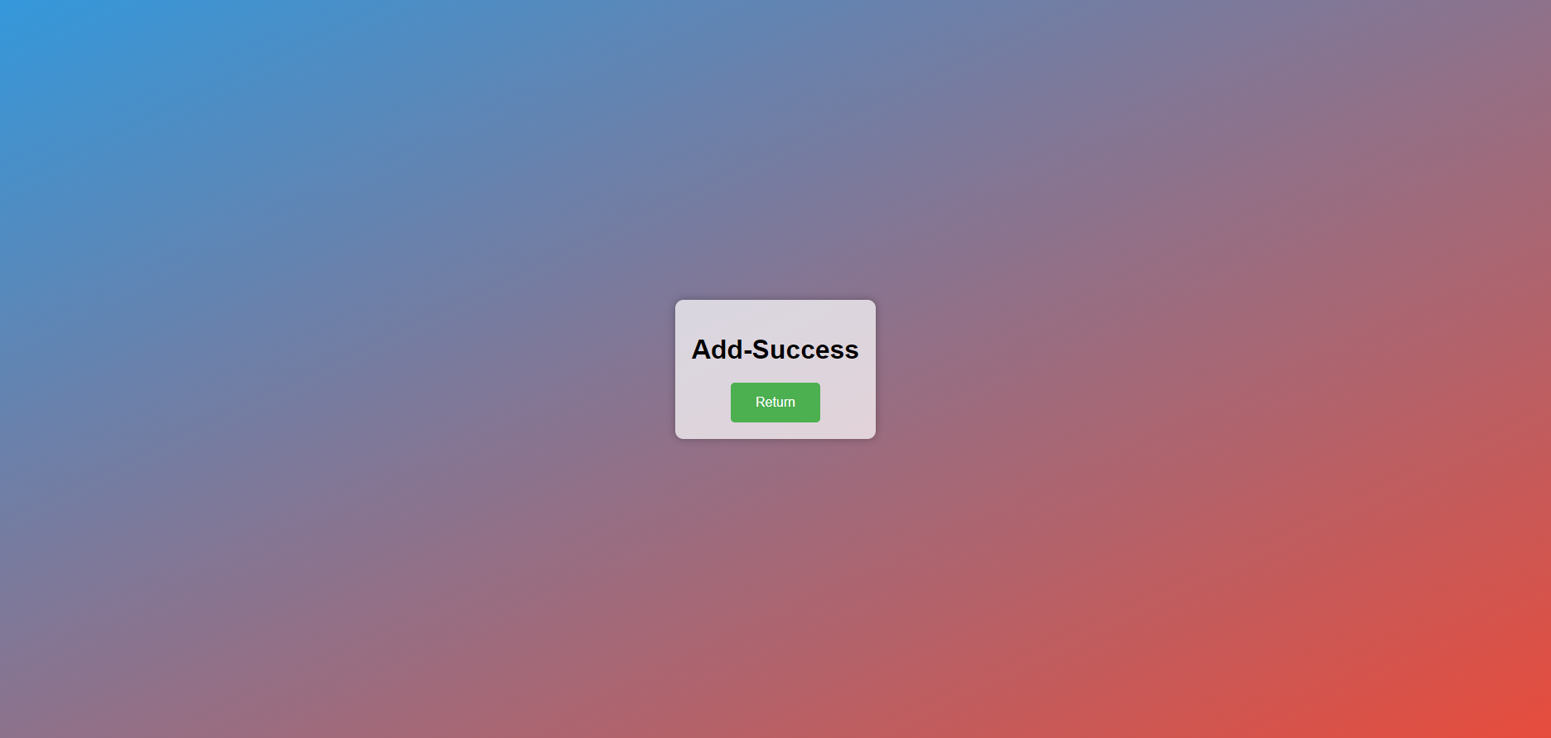

Now you can click the “Return” button go back to history page.

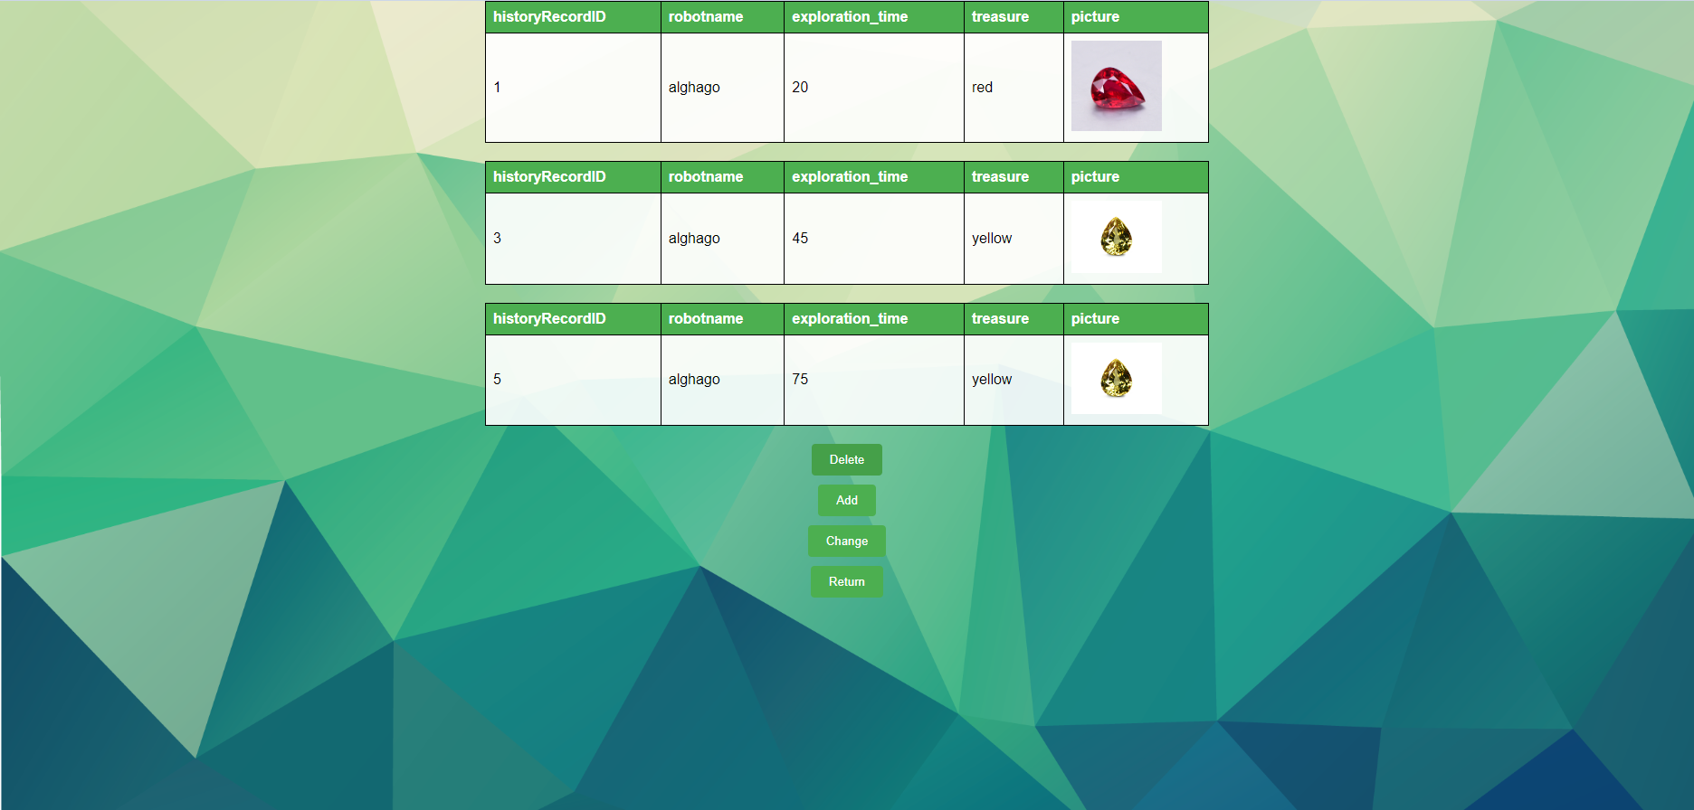

You can see that the recently added historical records are displayed on the page.

The updated database is shown in the following diagram.

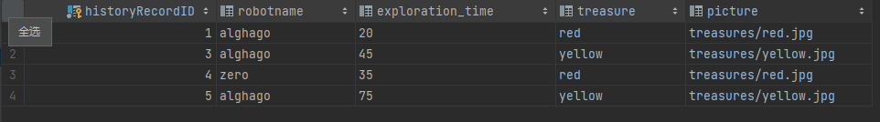

1. **Change Function**

After clicking the “Change” button, the page will automatically redirect to change page.

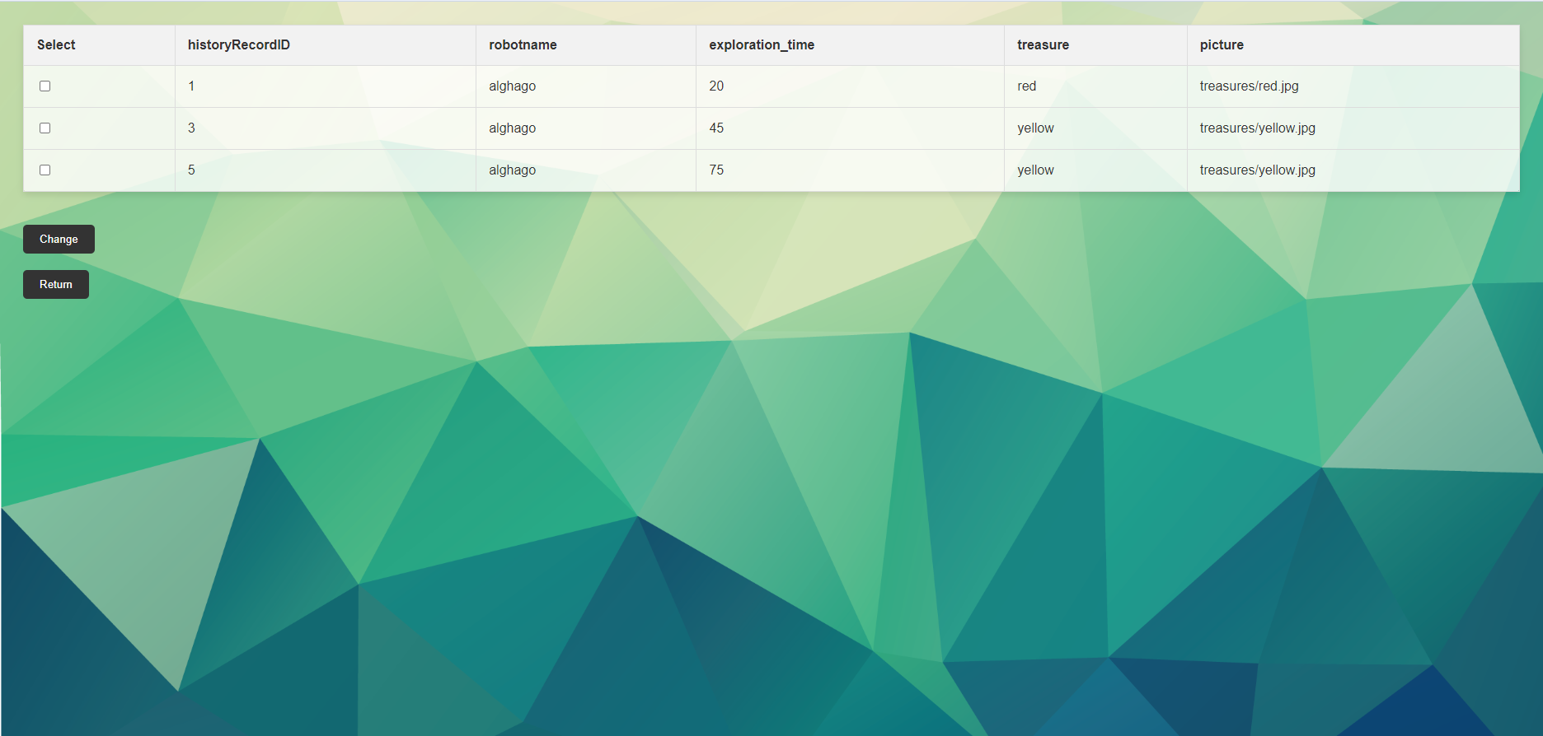

Select the data you want to modify in the checkbox.

After clicking on change, you will enter the data modification page.

The text boxes currently default to the original data.

If you want to change the data, please delete the original data in the corresponding field and enter the new data.

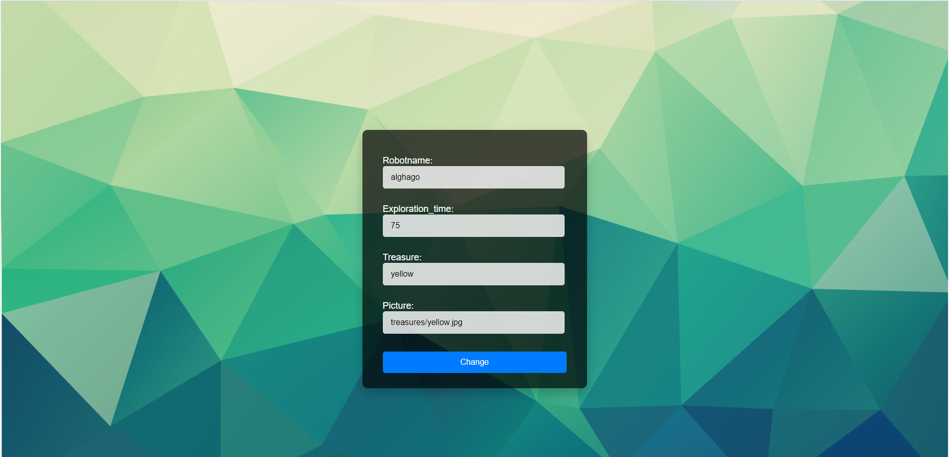

After clicking the “Change” button

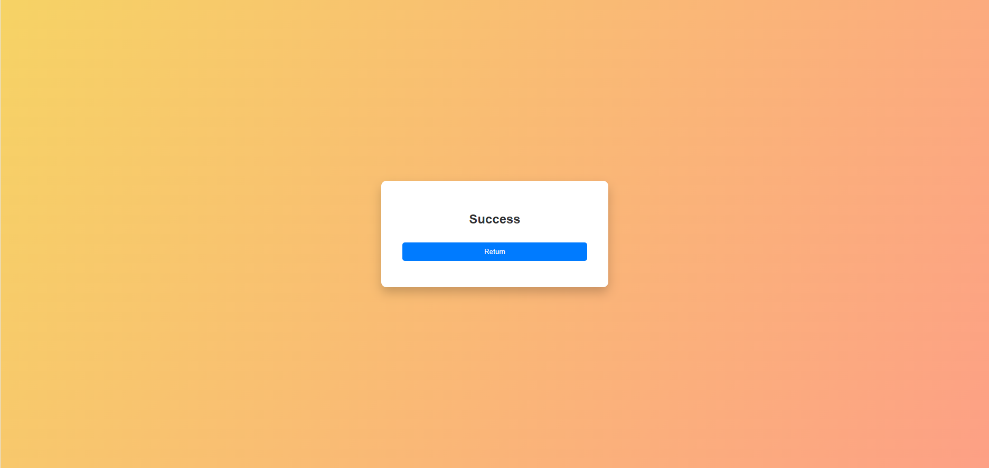

Now you can click the “Return button” go back to history page and you will see the data which is changed.

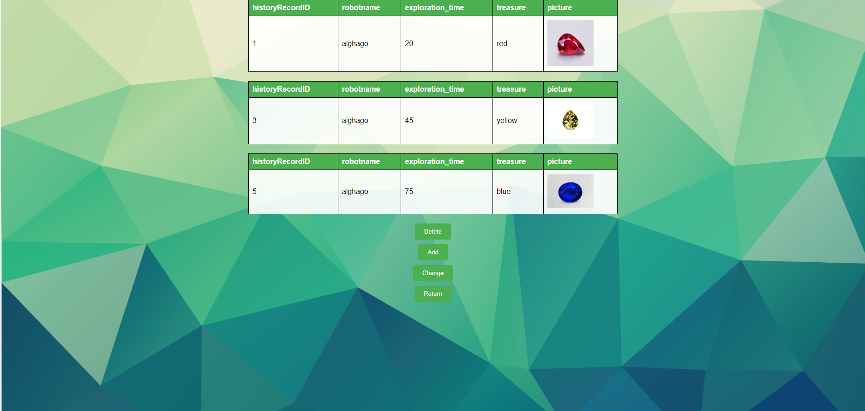

The updated database is shown in the following diagram.

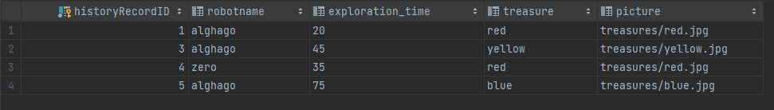

**(F) Log out Function**

After clicking the log out button, the account will be automatically logged out and redirected to the login page.



**(G) Log off Function**

After clicking “Log off” button



Click “Return” button and it will go back to login page.

At the same time, the corresponding account will be logged out and all user information, history records and real-time data related to the user and the corresponding robot will be deleted from the database.

The updated database is shown in the following diagram.

Userinfo table:



History table:



Exploration table:

